Traffic Violation Detection System

# Manas

Department of Information Technology,

Krishna Engineering College, Ghaziabad, U.P., India.

E-mail: [manas190701@gmail.com](mailto:manas190701@gmail.com)

# Chihit Gaur

Department of Information Technology,

Krishna Engineering College, Ghaziabad, U.P., India.

E-mail: [chihitgaur@gmail.com](mailto:chihitgaur@gmail.com)

# Abhishek Tyagi

Department of Information Technology,

Krishna Engineering College, Ghaziabad, U.P., India.

*Corresponding author*: [abhishektyagi1333@gmail.com](mailto:abhishektyagi1333@gmail.com)

**Dr. Rakesh Kumar Arora**

Associate Professor – Krishna Engineering College,

Krishna Engineering College, Ghaziabad, U.P., India.

E-mail: [rakesharora@krishnacollege.ac.in](mailto:rakesharora@krishnacollege.ac.in)

**Abstract**

Traffic accidents are one of the largest concerns in the world today. Accident rates are steadily increasing on a daily basis. The world is concerned about accidents, not just one nation. Every career nowadays demands total concentration on the job at hand. The driver's awareness is also the most crucial component when it comes to driving. Data indicate that 21% of all fatal accidents are caused by drunk driving. 60% of all adult drivers, or over 168 million drivers, acknowledged driving while fatigued the previous year [5]. This system will assist in reaching the objective by utilizing tools like OpenCV2 and YOLOv3. Traffic accidents are the number one cause of disability and mortality globally. In order to reduce human error and increase congestion relief, intelligent vehicle management does not largely rely on human resources. This article introduces an intelligent control system based on RFID technology. Using RFID technology, vehicles are linked to computer networks, intelligent light posts, and other reachable hardware along the way. This design makes use of an intelligent control system that can rack all vehicles, manage emergencies, monitor traffic, and keep track of traffic violations on a certain stretch of road.

**Keywords-** Traffic violation detection, Computer vision, Image processing, Object detection.

# Introduction

Traffic jams in urban areas may be caused by an increase in automobile ownership, indicating that traffic infractions are becoming more serious both domestically and globally. The severe property damage and subsequent accidents put lives at peril. To solve the problematic scenario and stop such horrific occurrences, technologies for traffic infraction detection are required. The system constantly enforces pertinent traffic laws and detains people who disobey them to stop this from happening. Since the authorities always keep an eye on the highways, a real-time traffic infraction detection system is required. Traffic enforcement officers won't have any trouble correctly and successfully enforcing safe routes since the traffic monitoring system detects violations more quickly.

# Related Work

Ou. G et al- performs real-time traffic violation identification in a monitoring stream by using parallel computing methods and concurrent video feeds from several cameras [1]. Wang.X et al- achieved real-time traffic violation identification in and then followed moving autos using feature-based tracking. This was done utilizing an improved background-updating algorithm and video-based traffic detection [2].

Although the project above served as inspiration for this one, it was seeded utilizing a self-developed process. Detecting vehicles is frequently referred to as an object detection problem. The ability to recognize moving vehicle objects from the road is provided by the YOLOv3 model, which uses Darknet-53. An evaluation of the circumstances surrounding the offence comes after vehicle detection.

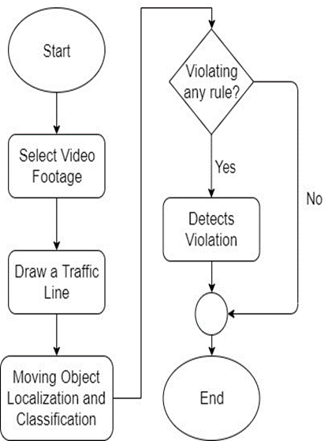

Figure-1 System Operation Depiction

System consists of two main components-

• Vehicle detection model

• A graphical user interface (GUI)

The roadside video footage is the first thing the system gets. The existence of cars is made clear throughout the movie. Technology keeps track of how the automobiles are moving and determines whether or not there has been a violation. The operation of the system is shown in Figure 1.

The Graphical User Interface (GUI) makes the system interactive for users. When a violation is discovered using the vehicle's bounding box, the user may view the traffic footage and get a warning. The user can do more thanks to the GUI.

# Methodology

In the supplied video clip, it is possible to spot moving objects. The object detection model YOLOv3 is used to classify these moving objects into the proper categories. The third object detection technique in the YOLO (You Only Look Once) family is known as YOLOv3. It has many techniques to boost accuracy and is better at recognizing items. The classifier model is built using the Darknet-53 architecture.

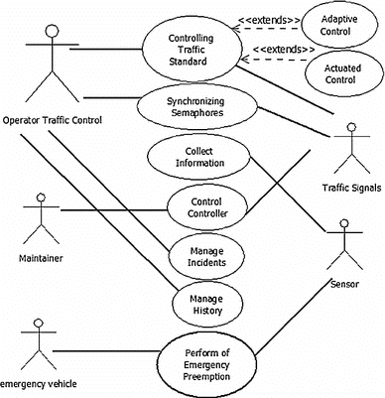

Figure-2 Use case diagram

**Features:**

1. Bounding Box Predictions: The loss for objectivity and classification must be calculated separately using the same network because YOLOv3 is a single network. The objectiveness score is predicted by YOLOv3 using logistic regression, where 1 indicates a bounding box prior that entirely encloses the ground truth object. It will only predict 1 bonding box prior for each ground truth item, and any error there will lead to both classification and detection loss. There would also be other bounding box priors with objectiveness scores above the cutoff but below the ideal one. These issues will only affect the detection loss; the classification loss won't.
2. Class Prediction: Jiménez, F et al- predicts for each class, YOLOv3 uses a different logistic classifier rather than the conventional SoftMax Layer. To construct a multi-label classification is the goal here. Each box anticipates the classes that the bounding box could include using multilabel categorization [14].
3. Predictions across scales: To make size changes easier to recognize, YOLOv3 anticipates boxes at three different scales. The features are then extracted from each scale using a technique similar to feature pyramid networks. By employing the aforementioned method, YOLOv3 improves its ability to make predictions of different sizes. Three scales of three bounding box priors each make up the dimension clusters utilized to create the bounding box priors, for a total of nine bounding box priors.
4. Feature Extractor: Unknown Network YOLOv3 makes advantage of Darknet-53. Darknet-53 has 53 convolutional layers, 53 residuals, and shortcut connections, making it more complex than YOLOv2. It is more powerful than Darknet-19 and more efficient than ResNet-101 or ResNet-152.

|  |  |  |  |  |
| --- | --- | --- | --- | --- |
|  | Type | Filters | Size | Output |
|  | Convolutional | 32 | 3 x 3 | 256 x 256 |
|  | Convolutional | 64 | 3 x 3 / 2 | 128 x 128 |
| 1x | Convolutional  Convolutional  Residual | 32  64 | 1 x 1  3 x 3 | 128 x 128 |
|  | Convolutional | 128 | 3 x 3 / 2 | 64 x 64 |
| 2x | Convolutional  Convolutional  Residual | 64  128 | 1 x 1  3 x 3 | 64 x 64 |
|  | Convolutional | 256 | 3 x 3 / 2 | 32 x 32 |
| 8x | Convolutional  Convolutional  Residual | 128  256 | 1 x 1  3 x 3 | 32 x 32 |
|  | Convolutional | 512 | 3 x 3 / 2 | 16 x 16 |
| 8x | Convolutional  Convolutional  Residual | 256  512 | 1 x 1  3 x 3 | 16 x 16 |
|  | Convolutional | 1024 | 3 x 3 / 2 | 8 x 8 |
| 4x | Convolutional | 512 | 1 x 1 |  |
| Convolutional | 1024 | 3 x 3 |  |
| Residual |  |  | 8 x 8 |
|  | Avgpool |  | Global |  |
|  | Connected |  | 1000 |  |
|  | Softmax |  |  |  |

Table 1 Darknet-53

# Violation Detection

Redmon, Josep et al- proposes YOLOv3 model is used to detect the cars. The incidents of violations are examined when the cars are found. In the user's preview of the provided video footage, a traffic line is painted across the road. The line clearly states that the light is red. Any car that crosses the traffic line while it is red is breaking the law.

The bounding box for the discovered items is green. Any infraction occurs when a vehicle crosses the center line when the light is red. The bounding box surrounding the car becomes red when a violation is discovered [3].

In order to find instances of traffic rule infractions, a traffic violation detection system analyses the behavior of the moving objects collected by sensors or surveillance cameras. The following steps are often included in this process:

1. Object Detection: Using computer vision algorithms, the system finds and locates automobiles inside the collected frames.
2. Behavior Analysis: To find probable infractions, the system examines the behavior of the observed cars. This may entail evaluating variables such vehicle speed, direction, lane usage, and adherence to traffic signs and regulations.

3. Rule-based or Machine Learning Models: To decide whether the observed behavior is a violation, the system uses predefined rules or machine learning models. In rule-based techniques, distinct infractions are determined by comparing the detected behavior to predetermined thresholds or criteria. From labelled data, machine learning models may learn to automatically identify patterns connected to certain breaches.

# Implementation

5.1 Computer vision:

This project uses the open-source computer vision and machine learning software package OpenCV for image processing. Implementing the car classifier with Darknet-53 makes use of TensorFlow.

A popular open-source library for computer vision and image processing applications is called OpenCV (Open-Source Computer Vision Library). It offers a complete collection of tools and algorithms that may be applied at different phases of a project for a traffic infraction detecting system. An outline of how OpenCV may be applied in the development of such a project is given below:

* 1. Data Acquisition and Preprocessing: OpenCV makes it possible to acquire and prepare video or picture feeds from security cameras or other sources. It offers tools for reading picture files, accessing video streams, and performing simple image preprocessing operations including scaling, cropping, and filtering.
  2. Object Detection and Tracking: OpenCV provides a number of algorithms and methods for detecting and tracking objects. Popular techniques include Haar cascades, Histogram of Oriented Gradients (HOG), and Deep Learning-based algorithms (like YOLO and SSD) are among them. These algorithms may be used to find and follow moving automobiles or other interesting things in the video frames that were taken.
  3. Violation Recognition: Algorithms for different kinds of traffic offences may be implemented using OpenCV. It may be used, for instance, to calculate vehicle speeds based on optical flow or frame-to-frame motion analysis. Red light infractions and inappropriate lane use may be identified with the help of OpenCV's feature extraction and matching algorithms.
  4. Image Enhancement and Analysis: OpenCV offers a broad variety of image processing tools that may be used to improve and examine collected frames. These processes include edge identification, contour analysis, edge filtering, and morphological procedures. Preprocessing, object segmentation, and feature extraction for traffic infraction detection can be aided by these approaches.
  5. Visualization and Reporting: By superimposing graphical annotations, bounding boxes, or text labels, OpenCV enables the visualization of processed frames and identified violations. It makes it easier to create educational visual reports or in-the-moment displays to support monitoring and analysis.
  6. Machine Learning Integration: OpenCV may be used in conjunction with machine learning frameworks (such as TensorFlow or PyTorch) to train unique object identification or recognition models designed exclusively for traffic infraction detection. Pre-trained models may be loaded, used, and easily included into the system for detecting traffic violations using OpenCV's features.

Developers may build numerous computer vision tasks required for a traffic infraction detection system thanks to OpenCV's extensive range of functions and algorithms. In order to efficiently and effectively create such systems, it streamlines the data collecting, preprocessing, object detection, violation recognition, and visualization processes.

5.2 Graphical User Interface (GUI):

The GUI provides all the settings the software need. The programme is used for administration and other types of debugging. We don't need to alter any management-related code. For instance, we may use the Open item (Figure-3) to open any video material.

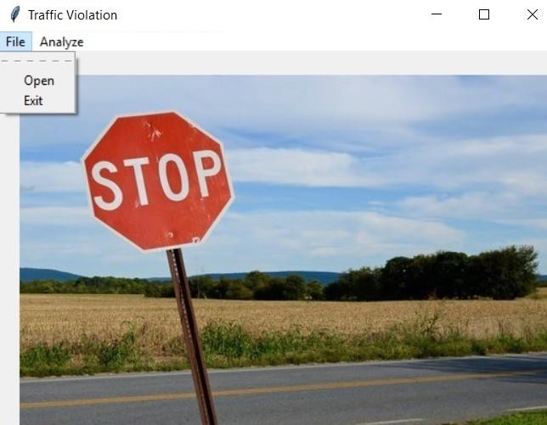

Figure 3 Initial user interface

The administrator must first open a video file using the 'Open' option under 'File' in order to begin utilizing the project (Figure 3). Any video file stored in the storage files can be opened by the administrator

(Figure 4).

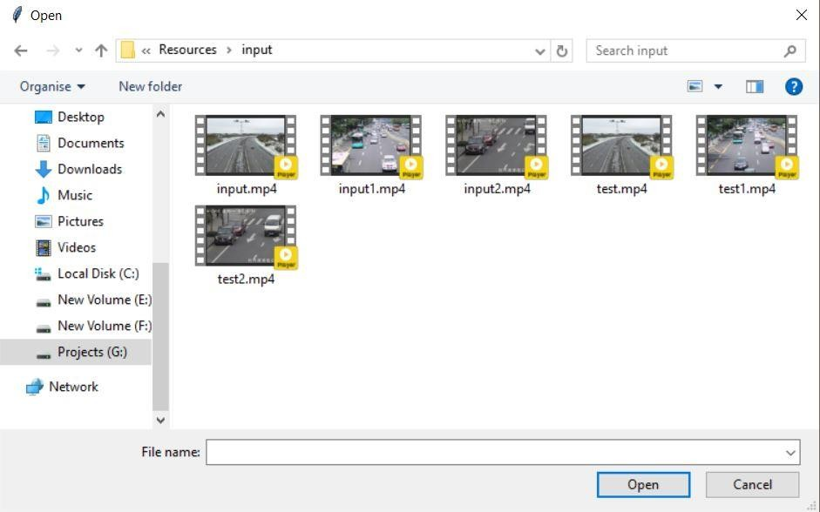

Figure 4 Opening a video footage

The system will obtain a preview of the video after opening it from storage. A frame from the video clip provided is included in the preview. Roads are identified and a traffic line is drawn across them using the preview. The administrator's designed traffic line will serve as a traffic signal line. The 'Region of interest' item under the 'Analyze' option must be selected in order to activate the line drawing capability (Figure 5). The administrator will next need to choose two places from which to construct a line defining the traffic signal.

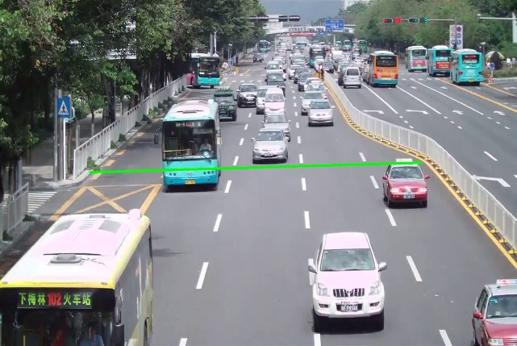

Figure 5 Region of Interest

The violation detection system will begin when you choose the area of interest. On the console, the coordinates of the drawn line will be displayed (Figure 5). The moment the line is drawn, the violation detecting system will activate. The weights will initially be loaded. The system will then look for violations after detecting items. The result will be displayed from the GUI frame-by-frame (Figure 6).

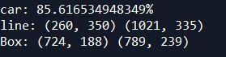

Figure 6 Line Coordinate (from console)

Up to the very last frame of the video, the system will display output. 'output.mp4' will be produced in the background. The file will be located in the Resources' "output" folder. By pressing "q," the procedure will be ended right away.

The administrator can upload further video material from the first file manager after processing one (Figure-3). When all work is finished, the administrator can exit by selecting the 'Exit' option from the File menu.

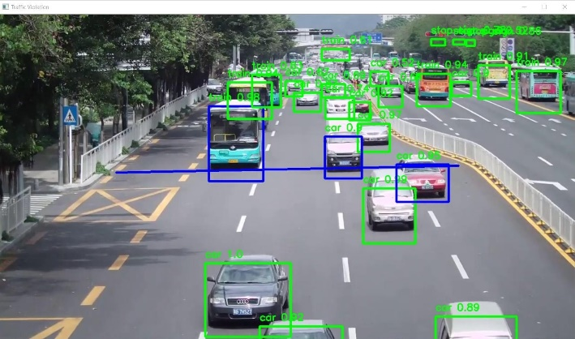

Figure 7 Final Output (on each frame)

# Implementation

Disobeying traffic signals is the project-specified form of infraction that the created algorithm effectively recognized. W. J. Horry et al- the threshold requirement for the indicated traffic infringement varies, which alters how the convergence of detection works. The technology provides detection of infractions at traffic signals. One data point can be processed at a time by the system [7]. The programme is also a touch slow when it runs. Utilizing a machine with a GPU or fast processor may be able to remedy this.

C.G. Keller et al- conducted further research on the algorithm's suitability for usage with other cutting-edge image processing techniques, as a result, by omitting additional unnecessary steps performed by a background difference approach, this may lengthen the time that the system's programme runs []. To give the system more intelligence, a computer vision algorithm may be used as an alternative. Our long-term objective is to improve this system by combining number plate detection and OCR support.

**Conflict of Interest**

The authors declare that there is no conflict for this publication.

**Acknowledgments**

This research did not receive any specific grant from funding agencies in the public, commercial, or not-for-profit sectors. The authors would like to thank the editor and anonymous reviewers for their comments that help improve the quality of this work.

# References

1. G. Ou, Y. Gao and Y. Liu, "Real Time Vehicular Traffic Violation Detection in Traffic Monitoring System," in 2012 IEEE/WIC/ACM, Beijing, China, 2012.
2. X. Wang, L.-M. Meng, B. Zhang, J. Lu and K.-L. Du, "A Video-based Traffic Violation Detection System," in MEC, Shenyang, China, 2013.
3. Joseph Redmon and Ali Farhadi, "YOLOv3: An Incremental Improvement".
4. Monitoring System,” in 2012 IEEE/WIC/ACM, Beijing, China 2012.
5. W, J, Horry.; Leach, M.F- Driver-Initiated Distractions: Examining Strategic Adaptation for In-Vehicles task Initiation. Acid. Anal. Prev. 2009,41,115-122.
6. Y, Dong.; Hu, Z.; Chimera, K.; Murayama, N. Driver In attention Monitoring System for Intelligent Vehicles: A Review. IEEE Intel. Transp. Syst. 2011, 12, 596–614.
7. W.J, Horry.; Leach, M.F Garbed, A. Assessing the Awareness of Performance Decrements in Distracted Drivers. Acid. Anal. Prev. 2008, 41, 675–682.
8. M, Eriksson.; Panicle polos, P.N. Driver Fatigue: A Vision-Based Approach to Automatic Diagnosis. Transp. Res. Part C Emerge. Technol. 2001, 9, 399–413. Sensors 2014, 14 22126.
9. J.C, McCall.; Trivedi, M.M. Video-Based Lane Estimation and Tracking for Driver Assistance: Survey, System, and Evaluation. IEEE INTAL. Transp. Syst. 2006, 7, 20–37.
10. U, Handan.; Kalie, T.; C.; Werner and, M.; Snellen, W.V. An Image Processing System for Driver Assistance. Image Vis. Comput. 2000,18, 367–376.
11. L.M, Bergama.; Nuevo, J.; Sotelo, M.A.; Berea, R.; Lopez, M.E. Real-Time system for monitoring driver vigilance. IEEE Intell. Transp. Syst. 2006, 7, 63–77.
12. A, Escalera.; Armingol, J.M.; Mata, M. Traffic sign recognition and analysis for intelligent vehicles. Image Vis. Comput. 2003, 12, 247–258.
13. A, Broggi.; Cerri, P.; Ghidoni, S.; Grisleri, P.; Jung, H.G. A New Approach to Urban Pedestrian Detection for Automatic Braking. IEEE Intell. Transp. Syst. 2009, 10, 594–605.
14. F, Jiménez.; Naranjo, J.E.; Gómez, O. Autonomous maneuvering systems for collision avoidance on single carriageway roads. Sensors 2012, 12, 16498–16521.
15. C.G, Keller.; Dang, T.; Fritz, H.; Jools, A.; Rabe, C.; Gavrila, D.M. Active pedestrian safety by automatic braking and evasive steering. IEEE Intell. Transp. Syst. 2011, 12, 1292–1304
16. Manas.; Chihit Gaur.; Abhishek Tyagi.; Traffic Violation Detection System.Vol.8, Number 3,547-554, Issue June2023
17. Dr. Rakesh Kumar Arora.; Chandani Jain.; Yash Gupta.; Automated System For Monitoring Smart Farms. International Journal of Modern Trends in Engineering and Research Vol.7 Issue 5 May’2020